# LPL Portal Update (Movin Legal)

Information of Server and Login Credential and Process -

**Bot Development Server -**

**Movin Legal URL - https://gateway.movinlegal.co.uk/login**

**Movin Legal Username - support2@lpropertylawyers.co.uk**

**Movin Legal Password - LPL2022**

**Hoowla URL –**

**Hoowla Username-**

**Hoowla Password –**

**PDD Made By: Ravi Rawal**

1. Login to hoowla website.

1. Login to Movin Legal website.

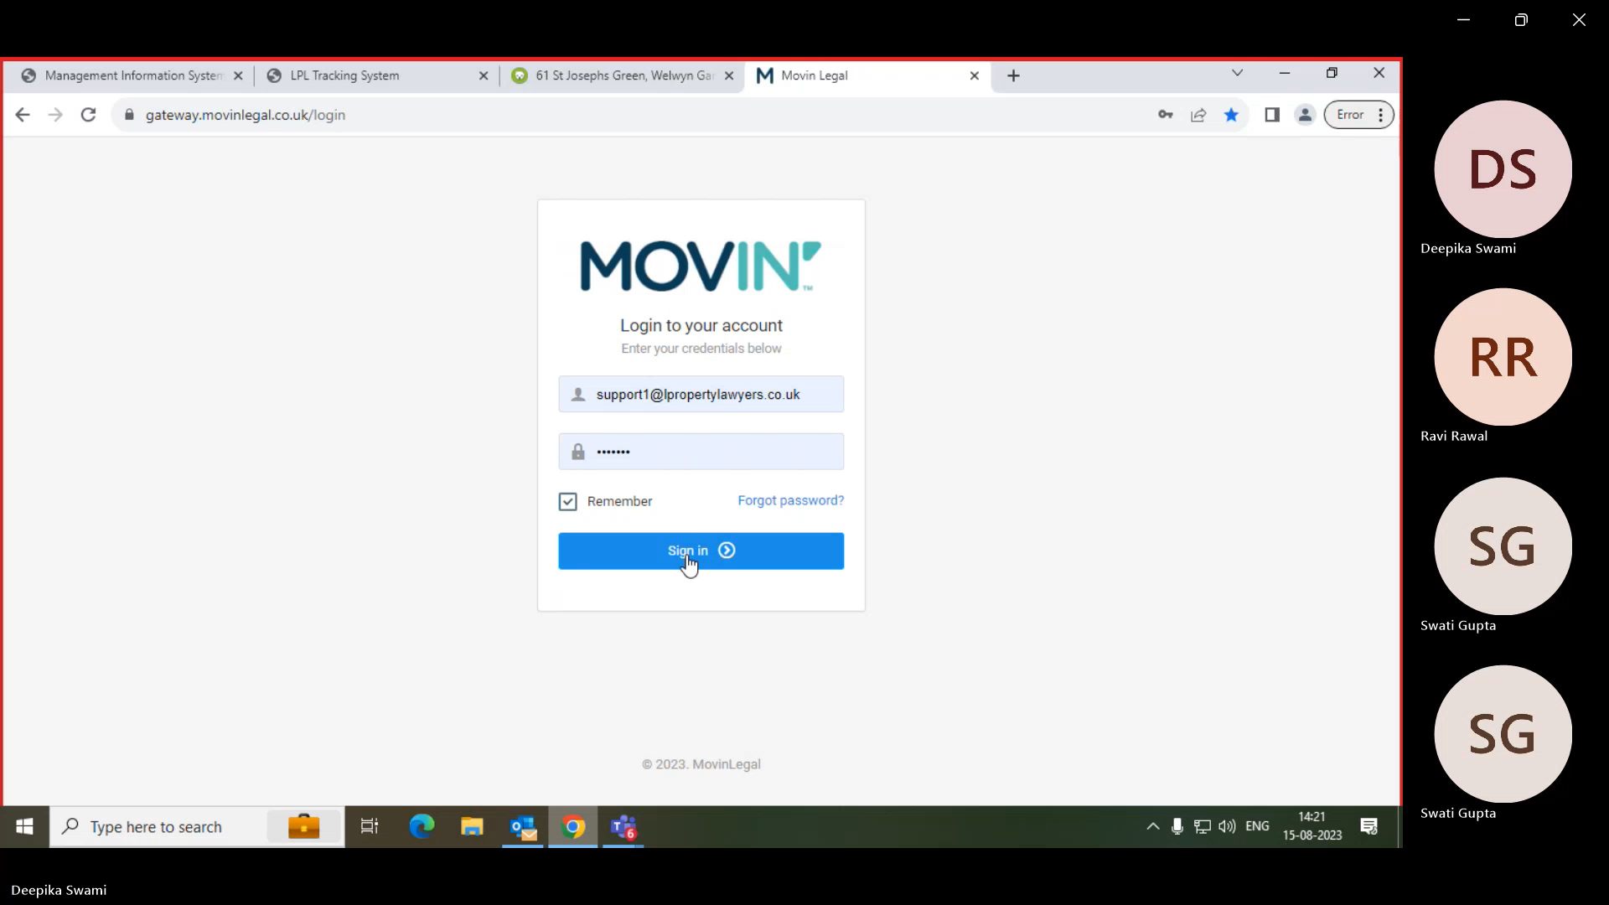

1. Search for Case references and click on view.

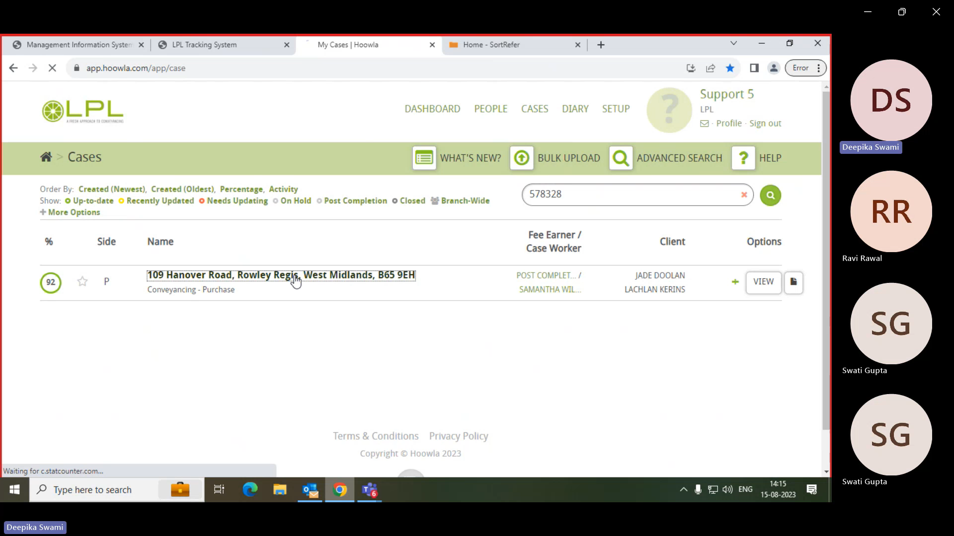

1. Extract the Client Name.

1. Extract the Completion Date and Property Address.

(Condition – If the completion date provided is a date in the future, then bot will encounter an error [Business Exception] in this scenario.)

1. Click on Cases then click on Active. Search the case by surname and validate the surname and click on view.

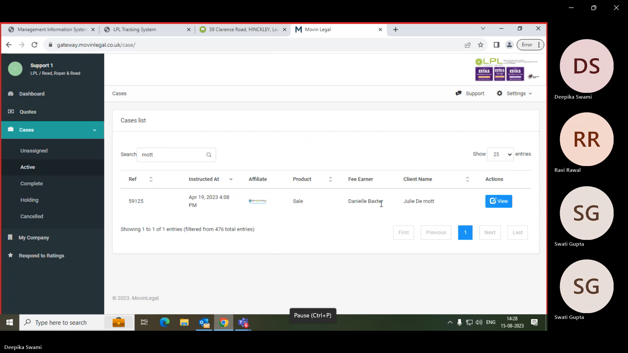



1. Click on the "Client Details" section and validate the property address (First Line and Postcode) with hoowla property address.

1. Click on Case status.

1. Click on Update milestones.

